Michigan EAB project – questions, methods, results
Aaron Tayal
Jan 24, 2025

Challenge paragraph (last paragraph of introduction):

Given the uncertain future of ash regeneration in the variety of forest types where ash is present, we initiated a project to assess the occurrence and health of ash in long-term research plots. Because soil hydrology (the degree of water saturation in the soil) is important for plant community composition, including the relative commonness of the three major species of ash, we used soil hydrology as our predictor variable. We asked whether the abundance of ash seedlings, saplings, and/or trees would differ based on the soil hydrological class of a forest stand. We did not make a specific hypothesis a priori regarding hydrological class. We did hypothesize that newly germinated ash seedlings would be absent from all stands, which would be consistent with the absence of seed-producing ash trees and the depletion of the ash seedbank. In addition to ash occurrence, we also asked if ash saplings and/or trees would show evidence of EAB attack. Consistent with previous studies, we expected that ash trees with larger diameters would have more signs and symptoms of EAB.

Methods:

Study area
This study was conducted in 37 transects previously established in 2004-2008 in mixed hardwood stands on public land within the Upper Huron River Watershed in southeast Michigan (Table S1) (Smith 2006; Klooster et al. 2014; Smith et al. 2015). Forest stands were originally selected in the Huron-Clinton Metroparks (Indian Springs, Kensington, and Hudson Mills) and Michigan State Recreation Areas (Pontiac, Highland, Proud Lake, and Island Lake) based on the density of ash and their proximity (24-45 km) to the epicenter of EAB invasion in Canton, Michigan (Siegert et al. 2014). Transects were initially characterized by the dominant ash species present (F. americana, F. pennsylvanica, or F. nigra) and edaphic conditions (xeric, mesic, or hydric soils) (Smith 2006; Klooster et al. 2014). Transects in well-drained upland forests with white ash were classified as xeric. Transects with moderately well-drained soils with white and/or green ash were classified as mesic. Transects in floodplains with water-saturated soils, standing water for part of the year, and black ash and/or green ash were classified as hydric. When these transects were first established, ash composed as average of 20-30% of the overstory basal area (Smith 2006). Other common tree genera in these stands included maple (Acer), oak (Quercus), cherry (Prunus), hickory (Carya), tuliptree (Liriodendron), aspen and cottonwood (Populus), elm (Ulmus), basswood (Tilia), hophornbeam (Ostrya), and musclewood (Carpinus) (Smith et al. 2015). Tree species community composition was driven partly by hydrological class, with hydric stands being distinct in composition from mesic and xeric stands (Smith 2006).

Transects consisted of three replicate 18 m radius circular plots (0.1 ha) with a multiscale sampling design to facilitate vegetation surveys (Fig. 1). Each plot is composed of an 18 m radius main plot , one nested 8 m radius subplot, and four 4 m² microplots, one in each cardinal direction. When these transects were established, all plots contained at least two ash (> 10 cm diameter at breast height, DBH). Additional details on plot establishment and characterization are provided in Smith 2006. In the main plot, subplot, and microplots, we resurveyed ash trees, small trees and saplings, and seedlings, respectively, during the growing seasons in 2024 and 2025.

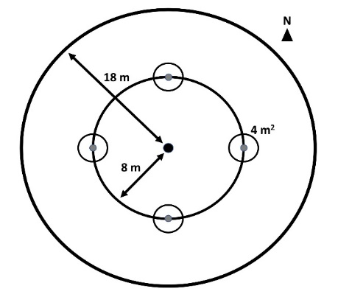

Ash abundance and health
To assess the abundance and health of ash, we surveyed overstory ash trees (≥10 cm DBH) within the 18 m radius main plots, understory ash trees (2.5-10 cm DBH) and ash saplings (≥137 cm in height but <2.5 cm DBH) within the central 8 m radius subplots, and ash seedlings (<137 cm in height) within the 4 m² microplots. All DBH measurements were taken at a height of 137 cm (Ward et al. 2021). Due to difficulties in distinguishing green and white ash, species designations were grouped into three categories: 1) black ash; 2) all other species of ash, including white ash, green ash, and potentially pumpkin ash; and 3) unknown ash species because the tree was dead. We reported the stem densities and basal areas of the species categories for each transect.

When present, canopy and understory ash were assessed individually for their condition. We rated the canopy condition using a 1 to 5 scale, where 1 represented a healthy canopy, 5 represented complete defoliation of the canopy, and 2-4 represented increasing stages of decline (Smith 2006; Klooster et al. 2014). For ash saplings the number of living stems were counted in the 8 m subplots. To survey established ash seedlings, the number of stems were counted in two height categories, <25 cm and >25 cm, and the percentage cover of total ash seedlings was estimated in the microplots (Klooster et al. 2014). We noted any seedlings with cotyledons which would indicate they were newly germinated (Klooster et al. 2014). All ash >2.5 cm DBH were assessed for signs and symptoms of EAB, including the presence of D-shaped emergence holes, woodpecker predation marks, bark splitting, epicormic sprouts, and basal sprouts (Knight et al. 2014).

EAB trapping

Parasitoid sampling

Statistical analysis
Plot-level densities of ash canopy and understory trees, seedlings, and saplings were calculated by dividing the number of stems by the area over which they were counted. All metrics of ash abundance are reported at the transect level. For ash canopy and understory trees, density of standing dead ash trees (canopy condition = 5) were calculated separately from density of living ash trees (canopy condition < 5). Basal area was calculated for living canopy and understory ash for each tree individually using the formula Σ(π*(d/2)²), where d is the DBH of a tree. Then, the areas of all understory trees were summed and then divided by the subplot area, and the areas of all canopy trees were summed and then divided by the plot area. Basal area was reported in units of m²/hectare. Due to a low number of observations, the density and basal area of canopy ash (> 10 cm dbh) were not tested statistically.

We used the existing categorization of transects (n=30) by hydrological class (xeric (18 transects), mesic (7 transects), and hydric (5 transects), Table S1) to test whether the abundance of ash differs based on soil moisture level. Our response variables were number of short ash seedlings (count), number of tall ash seedlings (count), mean percentage cover of ash seedlings (continuous), number of ash saplings (count), and number of living understory ash trees (count). We created separate models for each response variable. Hydrological class (xeric, mesic, or hydric) was treated as the fixed effect and Park where transect was located as random intercepts to account for unique site conditions at each of the seven parks. For each response variable which is count data, we first tried a Poisson generalized linear mixed-effects model (GLMM) with a log link function, implemented using the package ‘lme4’ in R . We used the package ‘DHARMa’ to determine if the observed data was adequately modelled by the GLMM (Hartig 2024). Whenever the Poisson GLMM was determined to be overdispersed, we created a new model using the negative binomial error structure. This was implemented using the ‘lme4’ and ‘MASS’ packages in R (Venables, Ripley, and Venables 2002). We similarly observed the residuals of the negative binomial GLMM to verify model fit. We compared the Akaike Information Criterion (AIC) between the Poisson and negative binomial models to verify an improvement in model fit. The models for number of saplings and number of understory trees were a singular fit or did not converge, so we dropped the random effect of Park for these response variables. The Anova function in the R package “car” (ref) was used to test for differences in the response variables among hydrological classes, and Tukey contrasts were calculated using the R package ‘emmeans’ (ref).

To assess differences in the percentage cover of ash seedlings along hydrological classes, the mean percentage cover of ash seedlings was calculated by averaging values across the 12 microplots in a transect (i.e., four microplots per plot x three plots). Due to issues with homoschedasticity of residuals, we transformed the response variable using the formula y’ = ln(y + 1), where y is the mean percentage cover. We developed a linear mixed-effects model using the R package X with the transformed mean percentage cover of ash seedlings as the response variable, hydrological class (xeric, mesic, or hydric) as the fixed effect predictor, and Park as random intercepts. The Anova function in the R package “car” (ref) was used to test for differences in the percentage cover of ash seedlings among hydrological classes, and Tukey contrasts were calculated using the R package ‘emmeans’ (ref).

To test the prediction that ash tree diameter is positively correlated with signs and symptoms of EAB attack, we used a generalized linear mixed-effects models with a binomial error structure. Diameter at breast height (DBH) was the fixed effect. We included plot as a random intercept to account for non-independence of trees in a plot. We excluded any tree belonging to a plot where less than 10 trees were found, which gave us a sample size of 274 trees. We further removed two trees which had missing values for presence of basal sprouts, which brought our sample size to 272 trees. To assess the accuracy of the models, we created binned categories of tree diameter and calculated the proportion of trees in each bin that showed the sign or symptom. We observed whether our model line passed through the proportions for each bin.

For the analysis of the canopy condition of ash trees (the stage of defoliation), this variable was initially recorded on a 1-5 scale, with 1 being a healthy canopy and 5 representing complete defoliation. To convert this measure into binary response variables, we created a response called “ash tree death” which was defined as 1 if canopy condition = 5, and 0 if canopy condition was between 1-4. We also created a response called “ash tree decline” which was defined as 1 if canopy condition was ≥ 2, and 0 if canopy condition = 1. We then analyzed these response variables similarly to the other signs and symptoms of EAB attack.

Results:

Of these, no seedlings had cotyledons, and thus no seedlings were newly germinated.

Ash seedlings (<137 cm in height):

Ash seedlings were found in stem densities ranging from 0 to 5.4 stems/m², with an average of 2.0 stems/m². Number of short ash seedlings varied by hydrological class (χ²=10.9, 2 df, p=0.004). Hydric transects had lower numbers of short seedlings than mesic (Z=-3.3, p=0.003) and xeric (Z=-2.6, p=0.027) transects, while differences between mesic and xeric transects were not statistically significant (Fig. 1A). Similarly, number of tall ash seedlings differed by hydrological class (χ²=12.7, p=0.002), with hydric transects having lower numbers than either mesic (Z=-3.5, p=0.001) or xeric (Z=-2.7, p=0.019) transects (Fig. 1B). Mean percentage cover of ash seedlings ranged from 0% to 38%, with an average of 12% across all transects. In mesic and xeric transects, the percentage cover of ash seedlings averaged 17% and 12%, respectively, but hydric transects had only 3% ash seedling cover on average. Percentage cover of ash seedlings varied by hydrological class (χ²=12.4, p=0.002), with hydric transects significantly lower than mesic transects (t=-3.2, p=0.010) and xeric transects (t=-3.0, p=0.018) (Fig. 1C).

Ash saplings (≥137 cm in height and <2.5 cm DBH):

The density of ash saplings, across the 30 transects, ranged from 0 to 0.539 stems/m² (0-5390 stems/hectare), with an average of 0.050 stems/m² (500 stems/hectare). Any differences in number of saplings based on transect hydrological class were not significant (χ²=0.4, p=0.82) (Fig. 1D). Signs or symptoms of EAB were found on 55 (5.5%) saplings. By far the most common symptom was bark splitting, which was found in 31 subplot quadrants out of 150 subplot quadrants with ash saplings. Other signs and symptoms of EAB were relatively rare or absent on ash saplings, including EAB exit holes (not found on saplings), woodpecker predation marks (found in 1 subplot quadrant), epicormic sprouts (found in 6 subplot quadrants), and basal sprouts (found in 3 subplot quadrants).

Ash small trees (2.5-10 cm DBH) and big trees (≥ 10 cm DBH):

A total of 187 understory ash trees were found in the 30 transects. Of these, 149 were living (canopy condition ≠ 5), while 38 were dead and at least partly standing. The density of living understory ash trees ranged from 0 to 1011 stems/hectare, with a mean of 82.3 stems/hectare. The number of living understory ash trees varied by hydrological class (χ²=8.38, p=0.015). Hydric transects had more understory ash trees than xeric transects (Z=2.5, p=0.033) (Fig. 1E).

Ash big trees (≥ 10 cm DBH):

Only 9 trees were found in the 30 transects, of which 7 were living (Fig. 1F). Living canopy trees within the plots ranged in diameter from 10.3 cm DBH to 12.4 cm DBH. The basal area of living understory and canopy ash trees (all ash ≥ 2.5 cm DBH and canopy condition ≠ 5) ranged between 0 and 2.61 m²/hectare, with an average of 0.18 m²/hectare.

B
A
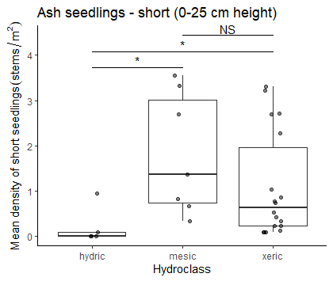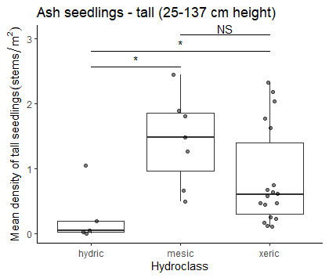
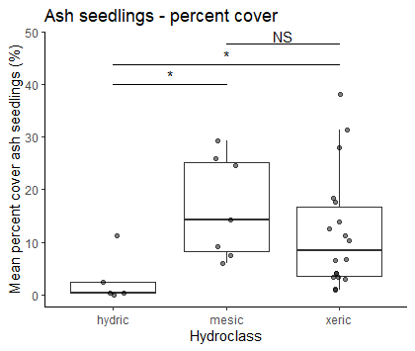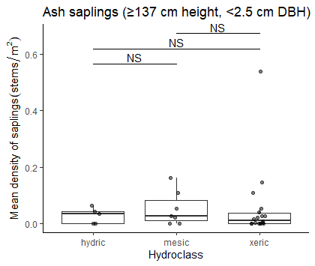
F
E
D
C
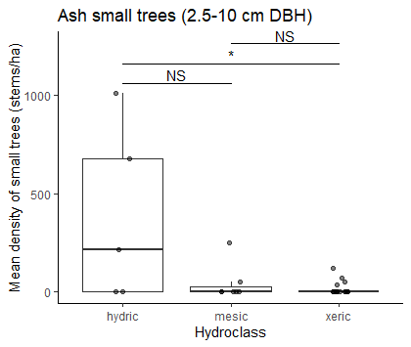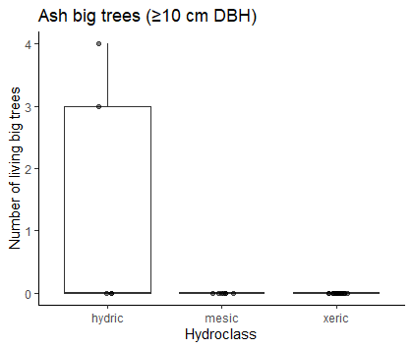
Figure 1. Ash occurrence by size category in 30 transects varying in soil hydrological class. A) Mean density of short ash seedlings, B) mean density of tall ash seedlings, C) percentage cover of ash seedlings, D) mean density of ash saplings, E) mean density of small ash trees, F) total counts of big ash trees.

Signs and symptoms of EAB on ash trees

Small and big ash trees were pooled for this analysis. D-shaped emergence holes from EAB were observed on a low percentage of understory and canopy ash, with only 8 ash trees (2%) having exit holes (Fig. S1).

Of the symptoms of EAB, bark splitting was the most common and was found on 179 (56%) ash trees. Epicormic sprouts were found on 116 (36%) ash trees. Basal sprouts and woodpecker predation marks were found on 46 (14%) and 40 (12%) ash trees, respectively.

Out of a total of 320 trees, 220 (69%) had canopy condition=1 (meaning they were healthy), 31 (10%) had canopy condition=2, 12 (4%) had canopy condition=3, 7 (2%) had canopy condition=4, and 50 (16%) had canopy condition=5 (meaning they had a dead canopy).

Relationship between ash tree diameter and EAB signs and symptoms

The presence of woodpecker predation marks was positively correlated with tree diameter (DBH), with a 1 cm increase in DBH increasing the odds of woodpecker marks by 130% (Z=2.96, p=0.003) (Fig. 2A). The relationship between DBH and bark splitting was not significant (Z=1.75, p=0.080) (Fig. 2B). Presence of epicormic sprouts was positively correlated with DBH, with a 1 cm increase in DBH increasing the odds of epicormic sprouts by 130% (Z=3.27, p=0.001) (Fig. 2C). The relationship between DBH and presence of basal sprouts was not significant (Z=1.75, p=0.080) (Fig. 2D). Additionally, the relationship between DBH and the tree having a canopy condition of 5 (meaning it is dead) was not significant (Z=0.73, p=0.465) (Fig. 2E). The presence of canopy foliage decline (canopy condition of 2-5) was positively correlated with DBH, such that a 1 cm increase in DBH increased the odds of canopy decline by 126% (Z=3.26, p=0.001) (Fig. 2F).

When examining the proportions of trees showing symptoms for groups binned by DBH, we noticed that the 9.5-10.5 cm group and the 10.5-11.5 cm group had lower-than-expected proportions of trees showing symptoms of EAB attack (Fig. 2, red triangles). Thus, the binomial GLMMs are not perfectly modelling the observed patterns. However, it must be noted that many of the ash in the 9.5-11.5 cm DBH range were from only one plot, plot 72 at Indian Springs.

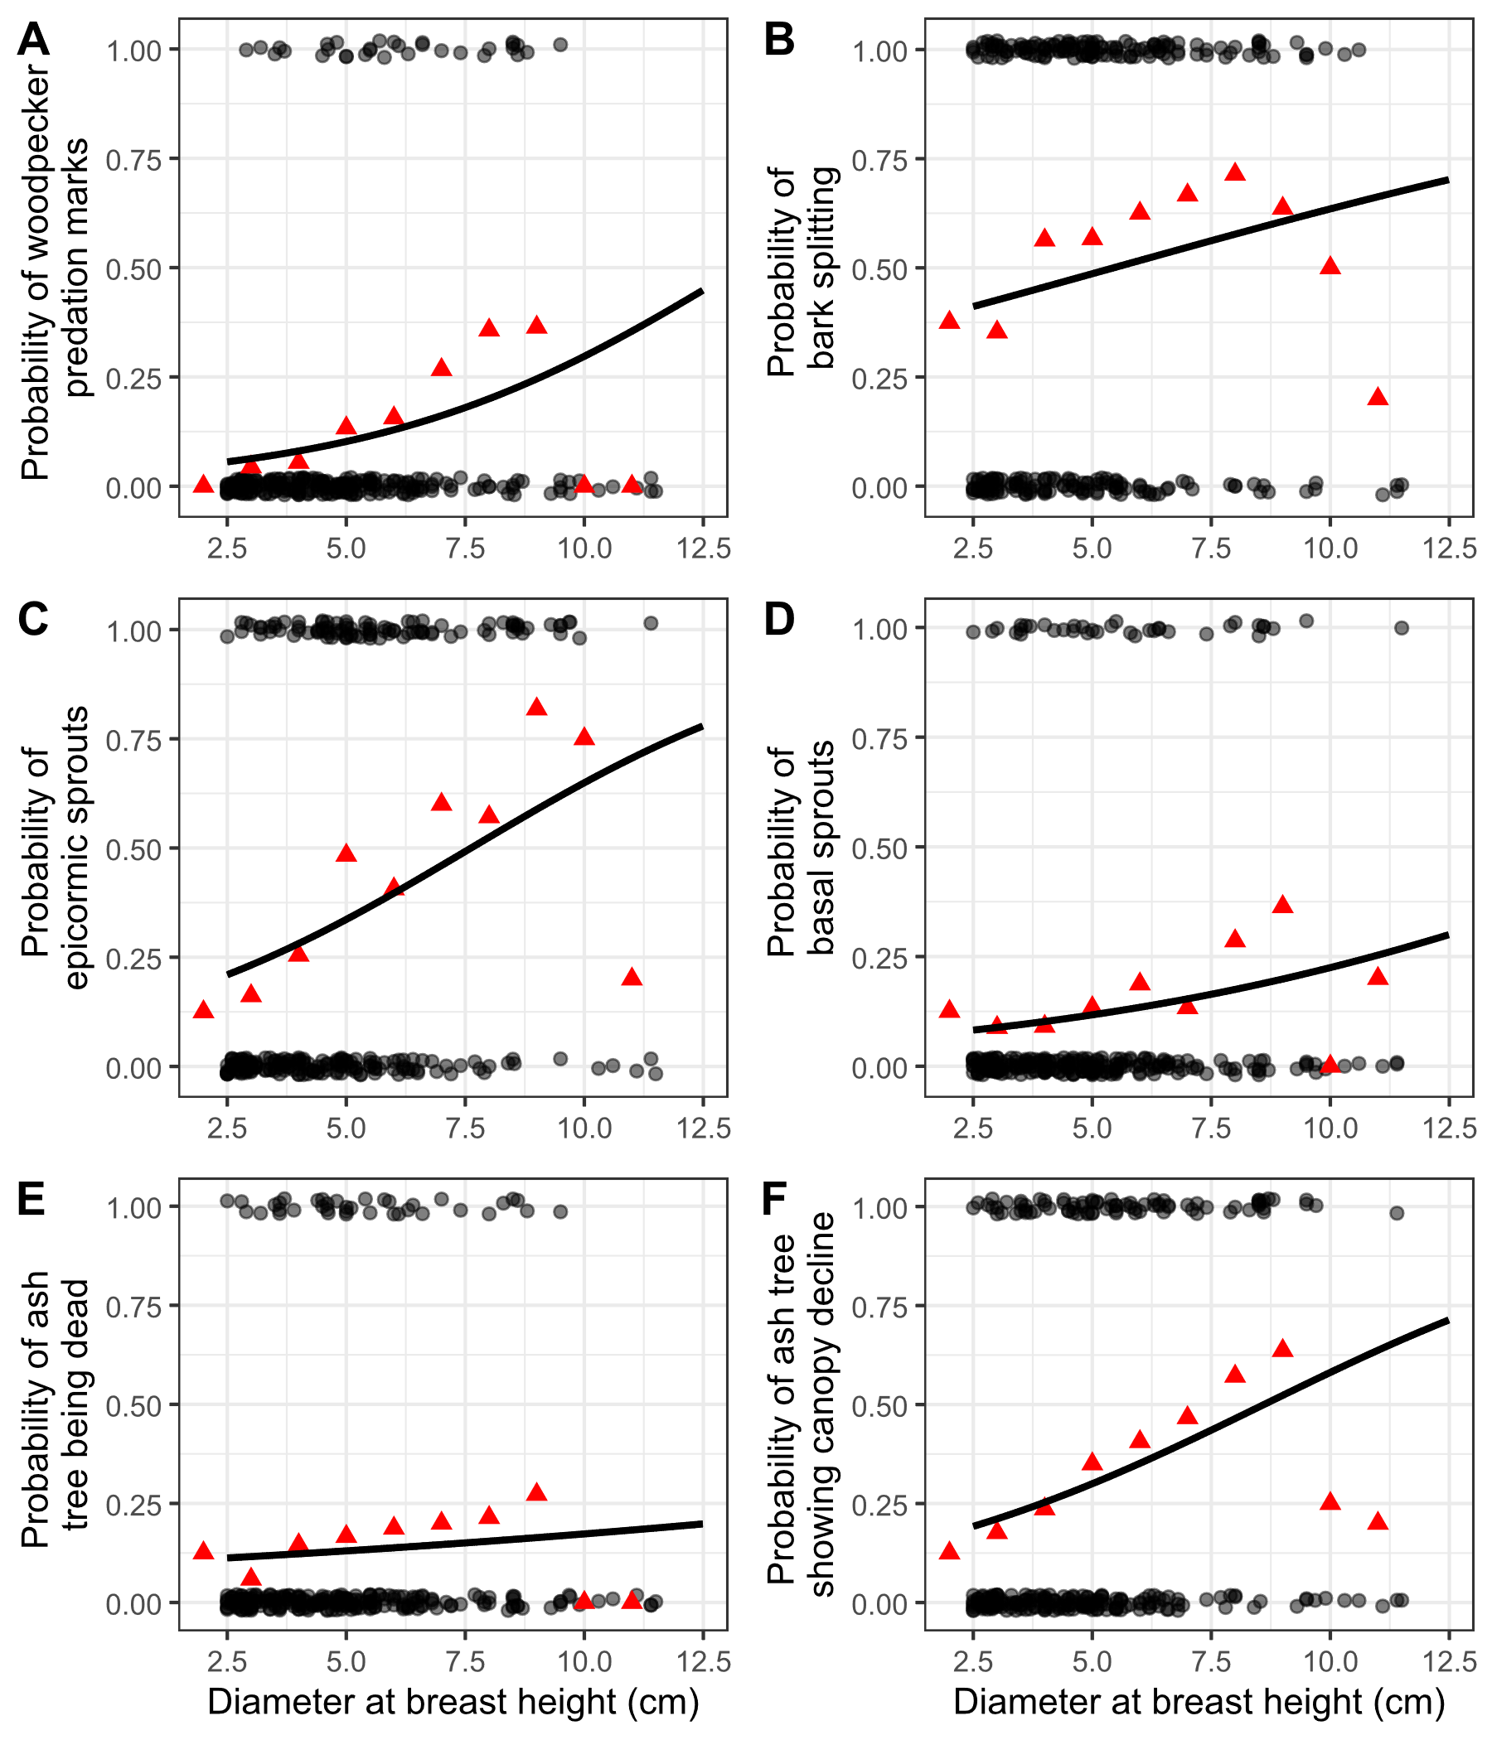
Figure 2. The presence or absence of symptoms of EAB plotted against tree diameter at breast height (DBH) for 272 trees in 9 forest plots. Grey circles are individual trees, which are plotted as y=1 for presence or y=0 for absence (points were jittered slightly up and down). Black line shows the overall fitted model, disregarding each specific random intercept for each plot. Red triangles show the proportion of trees within a DBH bin that have the symptom. For E, tree death is defined as a canopy condition of 5. For F, canopy decline is defined as a canopy condition between 2-5 (minor to complete defoliation).

Relationship between ash species, tree diameter, and canopy condition

The relationship between ash species, DBH, and canopy condition was investigated. Because the majority (280 out of 322) of ash trees (≥ 2.5 cm DBH) were found within hydric plots, we decided to subset the data to hydric plots for investigation of differences between ash species. After removing ash trees which were unidentified (17 trees) or with missing canopy condition (1 tree), we obtained a sample size of 157 black ash (Fraxinus nigra) trees and 105 trees which were either green ash (Fraxinus pennsylvanica) or pumpkin ash (Fraxinus profunda).

A higher proportion of the black ash trees were declining or dead, compared to the green and pumpkin ash, in the plots we surveyed (Figure 3). In contrast, in the 7.5-10 cm DBH range, there were nevertheless still more healthy (canopy condition = 1) black ash than green and pumpkin ash.

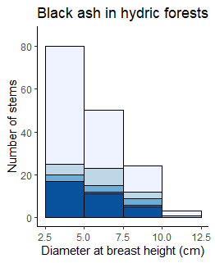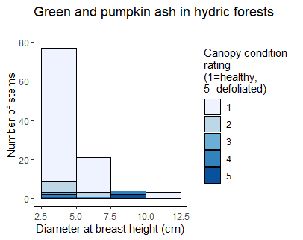
B
A
Figure 3. Histogram of ash tree diameter for different ash species found in hydric forests, shaded by canopy condition rating. The x-axes show diameter at breast height and the y-axes show aggregated counts of all trees found within plots. Bars are shaded according to the number of trees with each canopy condition rating, with darker shades indicating more canopy decline. Trees above 10 cm DBH were counted in 18 m radius main plots, while trees below 10 cm DBH were counted in 8 m radius subplots. A) Black ash (Fraxinus nigra) B) Green ash (Fraxinus pennsylvanica) and possibly pumpkin ash (Fraxinus profunda), which were not separated during species identifications.

Supplementary Tables

Table S1. Plot locations for the 111 plots visited in this study. Each set of three plots makes up a transect. Each transect was given a hydrological class of xeric, mesic, or hydric.

Plot  number | Plot name | Park | Transect | Latitude | Longitude | Hydrological  class
1 | KENUPHD | Kensington | A | 42.53254195 | -83.6705388 | xeric
2 | KENUPHD2 | Kensington | A | 42.53296724 | -83.67076505 | xeric
3 | KENUPHD3 | Kensington | A | 42.53326356 | -83.67093244 | xeric
4 | HMHD | Hudson Mills | AA | 42.37834666 | -83.91336117 | mesic
5 | HMHD2 | Hudson Mills | AA | 42.3779638 | -83.91309216 | mesic
6 | HMHD3 | Hudson Mills | AA | 42.37830402 | -83.91382332 | mesic
7 | KENDRY | Kensington | B | 42.53544514 | -83.66722319 | xeric
8 | KENDRY2 | Kensington | B | 42.53563361 | -83.66642756 | xeric
9 | KENDRY3 | Kensington | B | 42.53588209 | -83.66709668 | xeric
10 | HMDRY | Hudson Mills | BB | 42.37515735 | -83.91411337 | xeric
11 | HMDRY2 | Hudson Mills | BB | 42.37474575 | -83.91429938 | xeric
12 | HMDRY3 | Hudson Mills | BB | 42.37398156 | -83.91421887 | xeric
13 | KENUP | Kensington | C | 42.53463699 | -83.66695495 | xeric
14 | KENUP2 | Kensington | C | 42.53497995 | -83.66657034 | xeric
15 | KENUP3 | Kensington | C | 42.53429542 | -83.66721965 | xeric
16 | ILOPEN | Island Lake | CC | 42.49941418 | -83.7165664 | mesic
17 | ILOPEN2 | Island Lake | CC | 42.50011316 | -83.71690408 | mesic
18 | ILOPEN3 | Island Lake | CC | 42.49984426 | -83.71729405 | mesic
19 | KENDRY3 | Kensington | D | 42.53784433 | -83.66665362 | xeric
20 | KENDRY3A | Kensington | D | 42.53794168 | -83.66596685 | xeric
21 | KENDRY3B | Kensington | D | 42.53727952 | -83.66639485 | xeric
22 | ILLOW | Island Lake | DD | 42.49971912 | -83.71630958 | hydric
23 | ILLOW2 | Island Lake | DD | 42.50085549 | -83.7166848 | hydric
24 | ILLOW3 | Island Lake | DD | 42.49794685 | -83.71775494 | hydric
25 | PLINT | Proud Lake | E | 42.5759159 | -83.52099242 | xeric
26 | PLINT2 | Proud Lake | E | 42.57601569 | -83.52054316 | xeric
27 | PLINT3 | Proud Lake | E | 42.57637225 | -83.52026922 | xeric
28 | HLMAT | Highland | EE | 42.64473456 | -83.56669535 | xeric
29 | HLMAT2 | Highland | EE | 42.64590976 | -83.56680506 | xeric
30 | HLMAT3 | Highland | EE | 42.64686284 | -83.56915982 | xeric
31 | PLDRYMAT | Proud Lake | F | 42.57578816 | -83.52318352 | xeric
32 | PLDRYMAT2 | Proud Lake | F | 42.57577574 | -83.52399007 | xeric
33 | PLDRYMAT2A | Proud Lake | F | 42.57635459 | -83.52182426 | xeric
34 | PLCONF | Proud Lake | G | 42.57571524 | -83.52814029 | xeric
35 | PLDRYMAT3 | Proud Lake | G | 42.57581763 | -83.52740826 | xeric
36 | PLDRYMAT3A | Proud Lake | G | 42.57607392 | -83.52668128 | xeric
37 | PLWET | Proud Lake | H | 42.5747667 | -83.54598723 | hydric
38 | PLWET2 | Proud Lake | H | 42.57474279 | -83.54632682 | hydric
39 | PLWET3 | Proud Lake | H | 42.57428658 | -83.54708265 | hydric
40 | KENWET | Kensington | I | 42.53043348 | -83.67041583 | hydric
41 | KENWET2 | Kensington | I | 42.53110591 | -83.66746124 | hydric
42 | KENWET4 | Kensington | I | 42.53118814 | -83.66648081 | hydric
43 | KENWET3 | Kensington | J | 42.53124676 | -83.66897599 | hydric
44 | KENWET3A | Kensington | J | 42.53101609 | -83.66944111 | hydric
45 | KENWET3B | Kensington | J | 42.53146534 | -83.6685188 | hydric
49 | PONUP | Pontiac Lake | L | 42.67601991 | -83.48374379 | xeric
50 | PONUP2 | Pontiac Lake | L | 42.67639534 | -83.48336561 | xeric
51 | PONUP3 | Pontiac Lake | L | 42.67695181 | -83.48354417 | xeric
52 | PONHD | Pontiac Lake | M | 42.67737591 | -83.4842027 | mesic
53 | PONHD2 | Pontiac Lake | M | 42.67763539 | -83.48494077 | mesic
54 | PONHD3 | Pontiac Lake | M | 42.67619344 | -83.48458083 | mesic
55 | PONEAST | Pontiac Lake | N | 42.67628637 | -83.48161802 | xeric
56 | PONEAST2 | Pontiac Lake | N | 42.67644003 | -83.48223133 | xeric
57 | PONEAST3 | Pontiac Lake | N | 42.67655527 | -83.4827693 | xeric
58 | PONRT | Pontiac Lake | O | 42.67697644 | -83.48225793 | xeric
59 | PONRT2 | Pontiac Lake | O | 42.67847161 | -83.4821571 | xeric
60 | PONRT3 | Pontiac Lake | O | 42.67796779 | -83.48337831 | xeric
61 | ILRIP | Island Lake | P | 42.50511387 | -83.711563 | hydric
62 | ILRIP2 | Island Lake | P | 42.50548015 | -83.71130397 | hydric
63 | ILRIP3 | Island Lake | P | 42.50506543 | -83.71105671 | hydric
64 | ILCC | Island Lake | Q | 42.49871458 | -83.71880034 | hydric
65 | ILCC2 | Island Lake | Q | 42.49826164 | -83.71911588 | hydric
66 | ILCC3 | Island Lake | Q | 42.49755544 | -83.7194028 | hydric
67 | ISMATDRY | Indian Springs | R | 42.70259786 | -83.49652337 | mesic
68 | ISMATDRY2 | Indian Springs | R | 42.70213825 | -83.49648848 | mesic
69 | ISMATDRY3 | Indian Springs | R | 42.70223513 | -83.49584728 | mesic
70 | ISLD | Indian Springs | S | 42.7016922 | -83.49741597 | hydric
71 | ISLD2 | Indian Springs | S | 42.70129243 | -83.49740698 | hydric
72 | ISLD3 | Indian Springs | S | 42.70142849 | -83.49779967 | hydric
73 | ISMATDE | Indian Springs | T | 42.7035437 | -83.49463936 | xeric
74 | ISMATDE2 | Indian Springs | T | 42.70375308 | -83.49415138 | xeric
75 | ISMATDE3 | Indian Springs | T | 42.70278921 | -83.49360562 | xeric
76 | ISRIP | Indian Springs | U | 42.70463303 | -83.49570897 | hydric
77 | ISRIP2 | Indian Springs | U | 42.70481219 | -83.494821 | hydric
78 | ISRIP3 | Indian Springs | U | 42.70487822 | -83.4940807 | hydric
79 | ISOPEN | Indian Springs | V | 42.70480262 | -83.49706373 | mesic
80 | ISOPEN2 | Indian Springs | V | 42.70388702 | -83.49893342 | mesic
81 | ISOPEN3 | Indian Springs | V | 42.7045196 | -83.49803841 | mesic
82 | HLMATFR | Highland | W | 42.6489291 | -83.55636056 | xeric
83 | HLMATFR2 | Highland | W | 42.64858561 | -83.55689617 | xeric
84 | HLMATFR3 | Highland | W | 42.64939898 | -83.55761483 | xeric
85 | HLRIP | Highland | X | 42.64587606 | -83.55093888 | mesic
86 | HLRIP2 | Highland | X | 42.64514371 | -83.55089568 | mesic
87 | HLRIP3 | Highland | X | 42.64637211 | -83.55062169 | mesic
88 | HLUP | Highland | Y | 42.6470476 | -83.55230573 | xeric
89 | HLUP2 | Highland | Y | 42.64705538 | -83.55397741 | xeric
90 | HLUP3 | Highland | Y | 42.6474566 | -83.55365762 | xeric
91 | HMMAT | Hudson Mills | Z | 42.37824499 | -83.91166168 | xeric
92 | HMMAT2 | Hudson Mills | Z | 42.37825474 | -83.91229145 | xeric
93 | HMMAT3 | Hudson Mills | Z | 42.3787298 | -83.91267589 | xeric
94 | PONNEW | Pontiac Lake | ZA | 42.67554541 | -83.48274071 | xeric
95 | PONNEW2 | Pontiac Lake | ZA | 42.67584028 | -83.4830424 | xeric
96 | PONNEW3 | Pontiac Lake | ZA | 42.67606664 | -83.48271281 | xeric
97 | PONRD | Pontiac Lake | ZB | 42.67546355 | -83.4821069 | mesic
98 | PONRD2 | Pontiac Lake | ZB | 42.67597751 | -83.48183457 | mesic
99 | PONRD3 | Pontiac Lake | ZB | 42.67611495 | -83.4822095 | mesic
100 | PONWH | Pontiac Lake | ZC | 42.67657235 | -83.48190157 | xeric
101 | PONWH2 | Pontiac Lake | ZC | 42.67696268 | -83.48095924 | xeric
102 | PONWH3 | Pontiac Lake | ZC | 42.67670871 | -83.48046038 | xeric
103 | ISBR | Indian Springs | ZD | 42.70640403 | -83.49342124 | hydric
104 | ISBR2 | Indian Springs | ZD | 42.70623663 | -83.4938222 | hydric
105 | ISBR3 | Indian Springs | ZD | 42.70670773 | -83.49360969 | hydric
106 | ISBRS | Indian Springs | ZE | 42.70572744 | -83.49386673 | hydric
107 | ISBRS2 | Indian Springs | ZE | 42.70535737 | -83.49412394 | hydric
108 | ISBRS3 | Indian Springs | ZE | 42.70514295 | -83.49498565 | hydric
109 | ISWH | Indian Springs | ZF | 42.70282112 | -83.49624363 | mesic
110 | ISWH2 | Indian Springs | ZF | 42.70256049 | -83.49579452 | mesic
111 | ISWH3 | Indian Springs | ZF | 42.70249606 | -83.49513887 | mesic
112 | KENNEW | Kensington | ZG | 42.53359794 | -83.67122473 | xeric
113 | KENNEW2 | Kensington | ZG | 42.53386003 | -83.67146597 | xeric
114 | KENNEW3 | Kensington | ZG | 42.5343776 | -83.6712658 | xeric

Supplementary figures

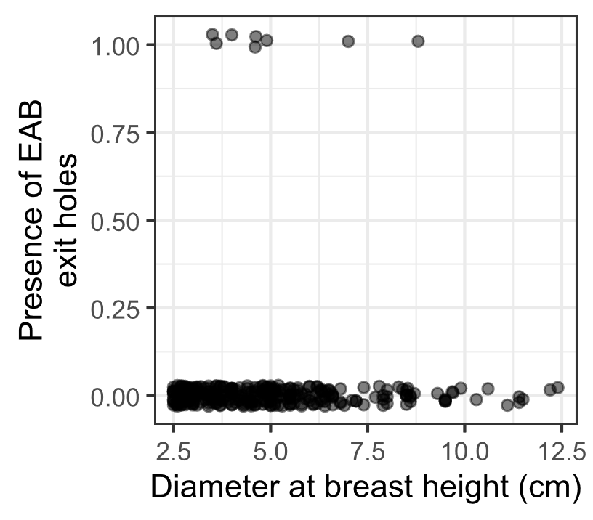
Figure S1. The presence or absence of visible EAB exit holes on the trunk at around eye level. Only 8 of 321 ash trees had EAB exit holes that were spotted.

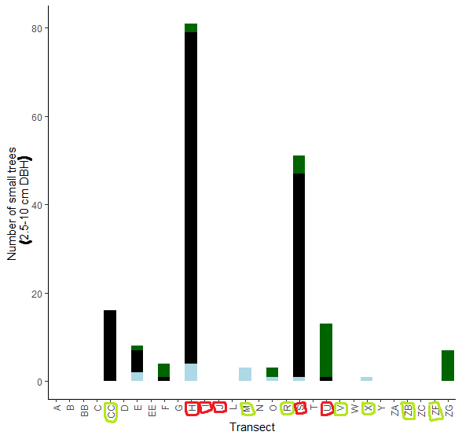
Figure S2. The total number of small ash trees (2.5 – 10 cm DBH) found in 30 completed transects in the Upper Huron River Watershed. Small ash of all canopy conditions are counted. Hydric transects are circled in red, while mesic transects are circled in light green. Bars are shaded based on the proportion of each ash species that was found in a transect. Dark green represents green, white, and/or pumpkin ash; black represents black ash; light blue represents unknown species.

References:

Hartig, Florian. 2024. “DHARMa: Residual Diagnostics for Hierarchical (Multi-Level / Mixed) Regression Models.” R. https://CRAN.R-project.org/package=DHARMa.
Klooster, Wendy S., Daniel A. Herms, Kathleen S. Knight, Catherine P. Herms, Deborah G. McCullough, Annemarie Smith, Kamal J. K. Gandhi, and John Cardina. 2014. “Ash (Fraxinus Spp.) Mortality, Regeneration, and Seed Bank Dynamics in Mixed Hardwood Forests Following Invasion by Emerald Ash Borer (Agrilus Planipennis).” Biological Invasions 16 (4): 859–73. https://doi.org/10.1007/s10530-013-0543-7.
Knight, Kathleen S., Britton P. Flash, Rachel H. Kappler, Joel A. Throckmorton, Bernadette Grafton, and Charles E. Flower. 2014. “Monitoring Ash (Fraxinus Spp.) Decline and Emerald Ash Borer (Agrilus Planipennis) Symptoms in Infested Areas.” General Technical Report NRS-139. U.S. Department of Agriculture, Forest Service, Northern Research Station. https://www.fs.usda.gov/research/treesearch/46655.
Smith, Annemarie. 2006. “Effects of Community Structure on Forest Susceptibility and Response to the Emerald Ash Borer Invasion of the Huron River Watershed in Southeast Michigan.” Master’s Thesis, The Ohio State University. http://rave.ohiolink.edu/etdc/view?acc_num=osu1394801603.
Venables, W. N., Brian D. Ripley, and W. N. Venables. 2002. Modern Applied Statistics with S. 4th ed. Statistics and Computing. New York: Springer.
Ward, Samuel F., Andrew M. Liebhold, Randall S. Morin, and Songlin Fei. 2021. “Population Dynamics of Ash across the Eastern USA Following Invasion by Emerald Ash Borer.” Forest Ecology and Management 479 (January):1–8. https://doi.org/10.1016/j.foreco.2020.118574.

